# Make FreeDOS USB Launcher

1. Make a DOS USB Launcher

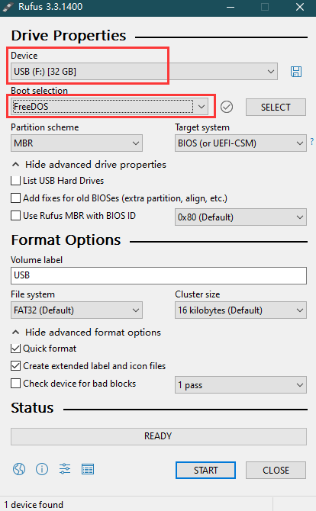

1. Put the AMI and SMBCFG folders into the root directory of the U disk

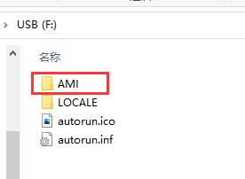

1. Press F11 at boot, select U disk, and enter DOS system

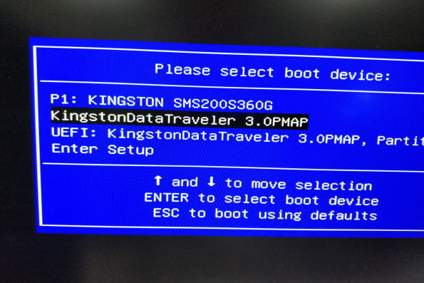

# AMI Update UUID

1. cd ami

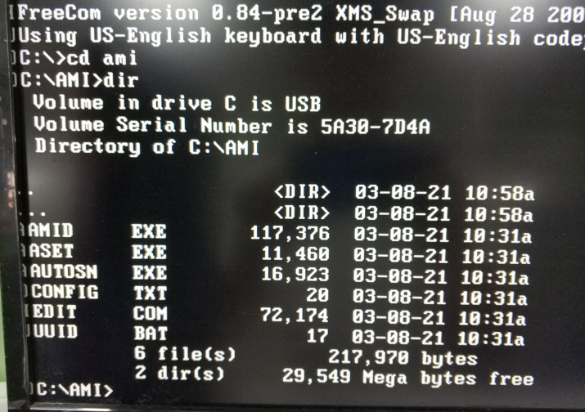

1. input uuid，Automatic flashing of randomly generated UUID

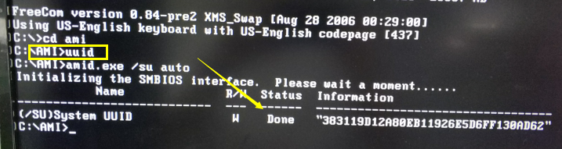

# SMBCFG update UUID

1. cd smbcfg

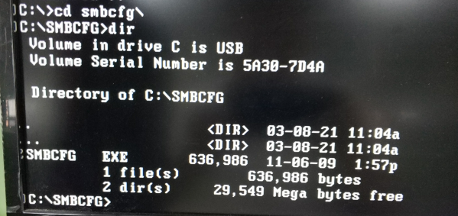

1. input smbcfg.exe——>press F2, select System, modify UUID——>press F10 to Save

